SCREEN SHOTS

Login Page

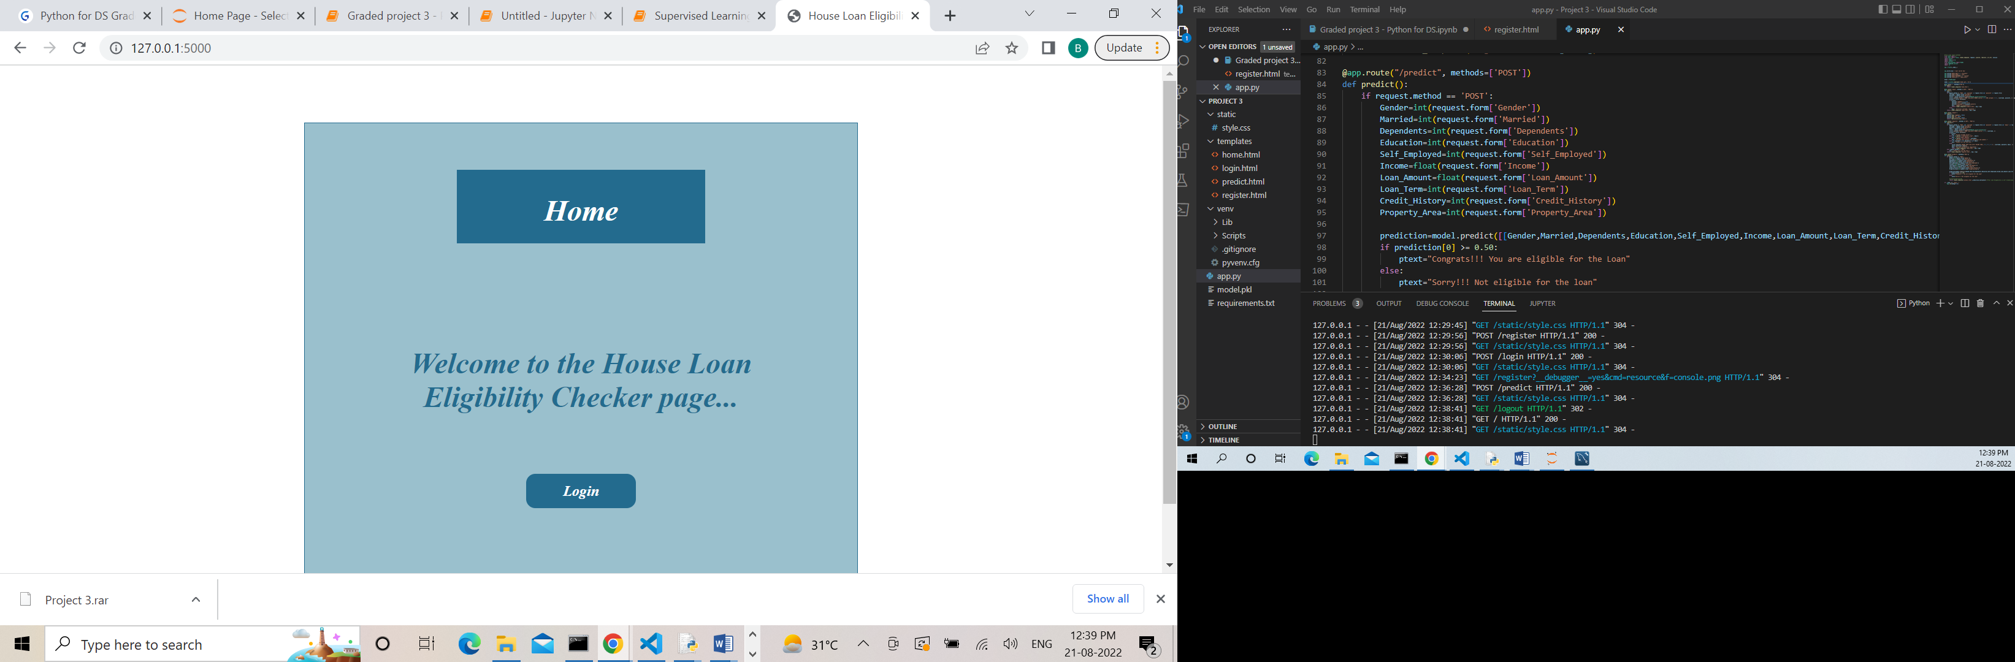

LOGIN PAGE

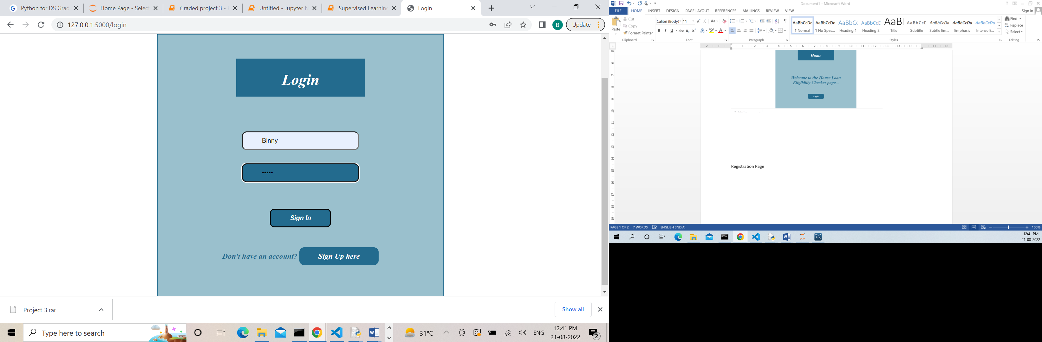

Registration Page

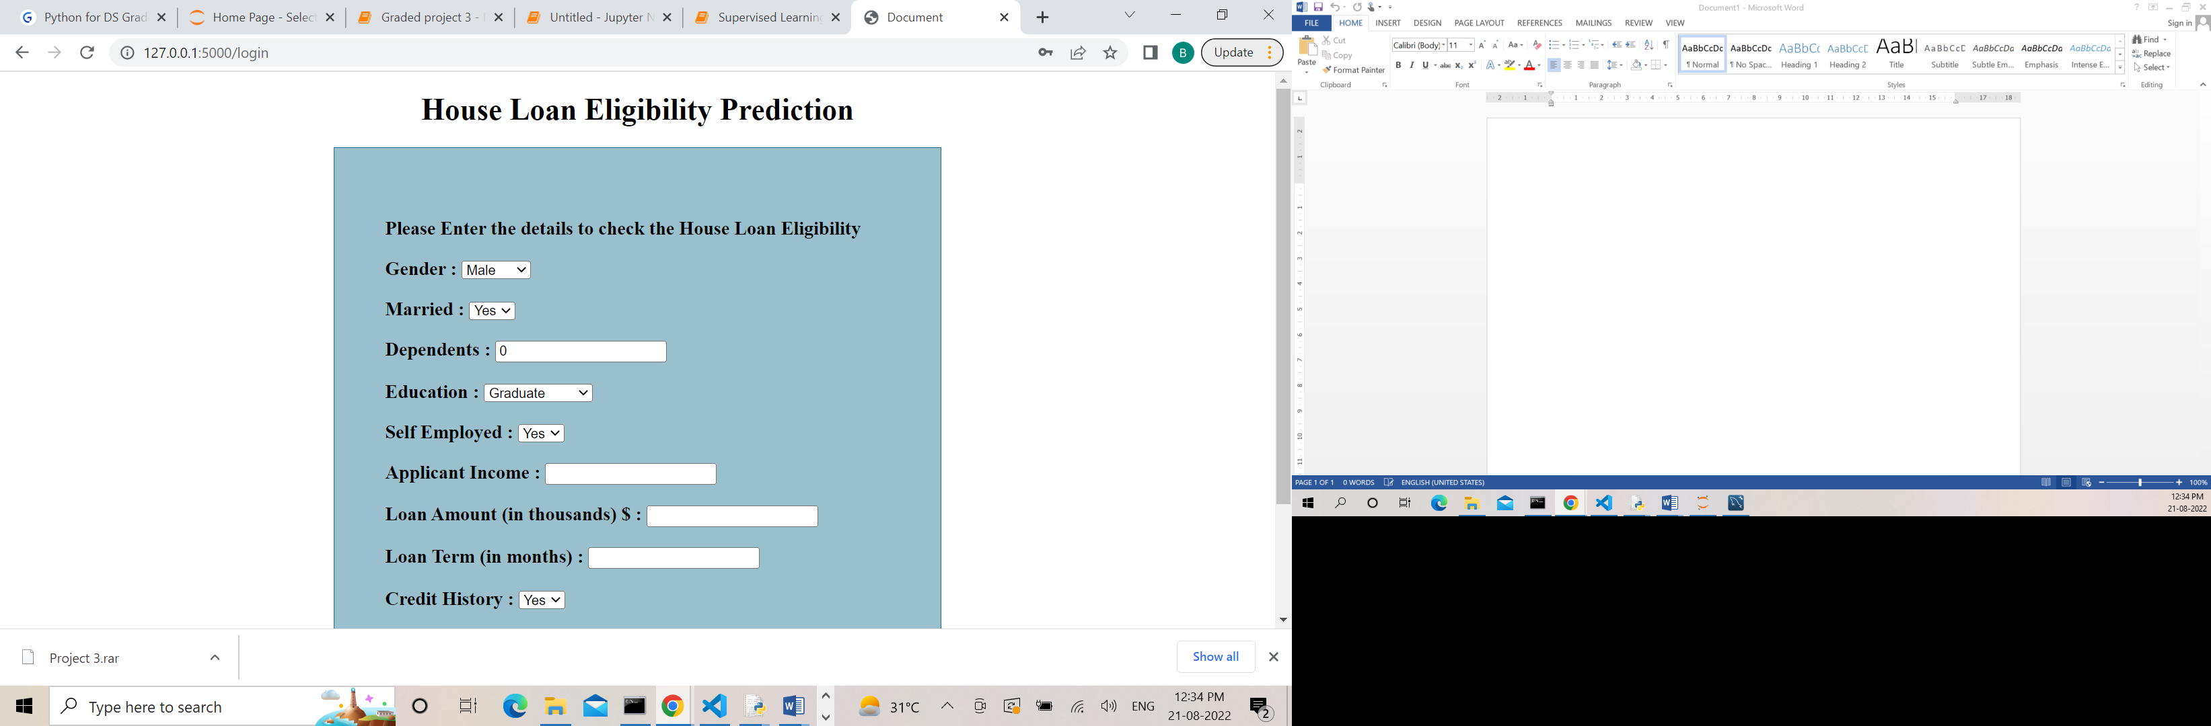

Predictability

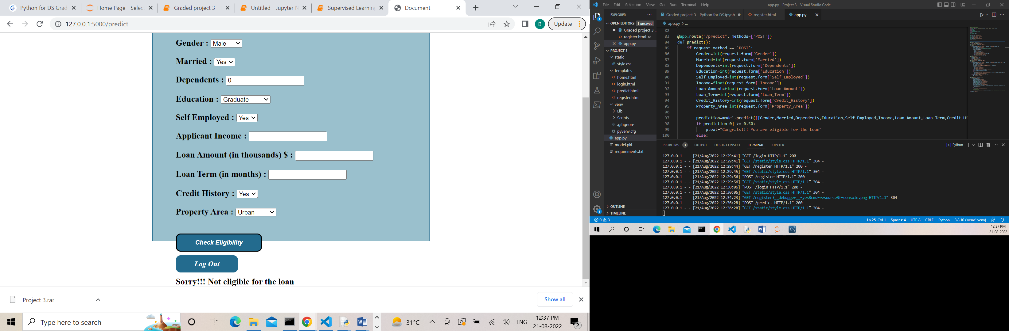

DATA IN THE DATABASE

